Postpartum Intrauterine Device
Activity # 3: What Is Different about the PPIUD?
Instructions for Facilitator

Time: 10 minutes

Objectives
The purpose of this activity is to:
- Identify instruments/items that are common—and different—about providing postpartum IUD (PPIUD) services and those for interval IUD services.
- Identify differences between the equipment and supplies needed for PPIUD and interval insertion.
- Consider differences in the characteristics of clients who come for PPIUD procedures compared with those of clients who come for interval procedures.

Materials needed: Instruments tray for PPIUD Insertion, Instruments tray for Interval IUD Insertion, flip chart paper, and markers.
Trainer’s Instructions
Before this exercise, set up the trays with instruments and essential supplies needed for an interval and a PPIUD insertion. Ask learners to gather around the skills station and brainstorm (rapid responses without much discussion) about:
- What is the difference about counseling a client for PPIUD?
- Timing and place of insertion?
- All the things they see are different about the setup for PPIUD insertion compared with interval IUD insertion.
Write their responses on a flip chart and discuss it with them. When the list seems sufficient, tell learners: “This is good for now. We will discuss it further during this session.”

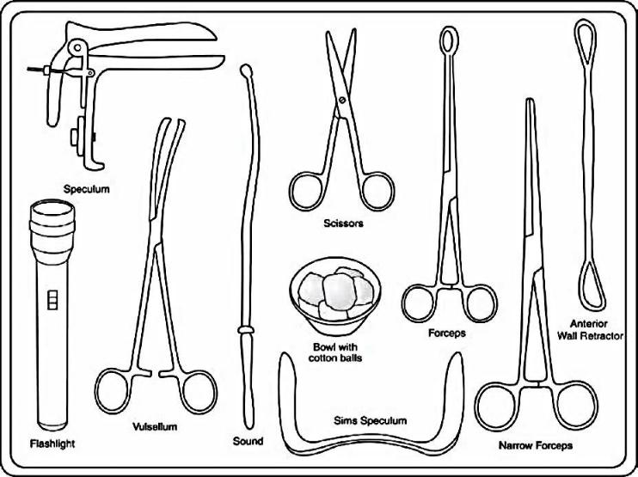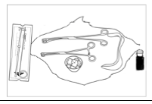

Interval IUD tray PPIUD Tray

